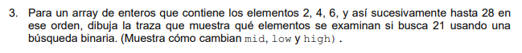
public class BusquedaBinaria {
public static void main(String[] args) {
int[] array = {2,4,6,8,10,12,14,16,18,20,22,24,26,28};
int objetivo = 21;
int low = 0;
int high = array.length - 1;
while (low <= high) {
int mid = (low + high) / 2;
System.out.println("low: " + low +
" high: " + high +
" mid: " + mid +
" valor(mid): " + array[mid]);
if (array[mid] == objetivo) {
System.out.println("Elemento encontrado en índice " + mid);
return;
}
if (array[mid] < objetivo) {
low = mid + 1;
} else {
high = mid - 1;
}
}
System.out.println("Elemento no encontrado");
}
}

public class Main {
public static void main(String[] args) {
int[] array = {2, 4, 6, 8, 10, 12, 14, 16, 18, 20, 22, 24, 26, 28};
int objetivo = 21;
int low = 0;
int high = array.length - 1;
while (low <= high) {
int mid = (low + high) / 2;
System.out.println("low: " + low +
" high: " + high +
" mid: " + mid +
" valor(mid): " + array[mid]);
if (array[mid] == objetivo) {
System.out.println("Elemento encontrado en índice " + mid);
return;
}
if (array[mid] < objetivo) {
low = mid + 1;
} else {
high = mid - 1;
}
}
System.out.println("Elemento no encontrado");
}
}

